Effectiveness of Plant-Based Repellents Against Aedes aegypti: A Systematic Review and Meta-Analysis

Mubarak¹*, Tri Baskoro Tunggul Satoto²
¹ Faculty of Medicine, Halu Oleo University, Kendari, Indonesia
² Faculty of Medicine, Public Health and Nursing, Gadjah Mada University, Yogyakarta, Indonesia

Abstract

Background: Aedes aegypti is a major vector of dengue, Zika, chikungunya, and yellow fever, particularly in tropical and subtropical regions. Plant-based repellents have been considered as accessible alternatives to synthetic compounds such as DEET and picaridin, but the available evidence is still scattered across plant species, formulations, and concentrations.
Objectives: This systematic review and meta-analysis assessed whether plant-based repellents reduce Aedes aegypti biting or landing outcomes and examined how effectiveness varied by plant category, formulation type, and concentration.
Methods: We searched PubMed/MEDLINE, Scopus, Web of Science, EMBASE, and Google Scholar for studies published up to March 2026. Studies were eligible when they evaluated plant-based topical repellents against Aedes aegypti and reported quantitative outcomes such as biting rate, landing rate, repellency percentage, or complete protection time. Two reviewers screened the records, extracted the data, and assessed risk of bias. The main effect measure was the risk ratio for biting or landing events in treated groups compared with control groups. A random-effects model was used because the included studies differed in plant species, formulation, concentration, and testing method. Heterogeneity and publication bias were assessed using standard meta-analysis procedures.
Results: Thirty studies with 3,958 participants or bioassay units were included in the analysis. Overall, plant-based repellents were associated with fewer Aedes aegypti biting or landing events than controls, with a pooled RR of 0.37 (95% CI: 0.31–0.43; p < 0.001). Heterogeneity was substantial (I² = 62.4%; τ² = 0.038), which may reflect differences in plant species, formulation, concentration, and testing conditions. Clove oil, neem oil, and lemon eucalyptus/PMD-based products showed the most consistent protective effects. Egger’s test did not suggest significant publication bias.
Conclusion: Plant-derived repellents may help reduce Aedes aegypti biting or landing, but their effects vary by plant species, formulation, and concentration. The findings suggest better protection from clove oil, neem oil, and lemon eucalyptus/PMD-based products. Further work is still needed to standardize testing methods, improve formulations, confirm field performance, and assess safety before wider use in vector-control programs.

Keywords: Aedes aegypti; botanical repellent; dengue vector control; essential oil; plant-derived compound; sustainable vector control.

Corresponding author: E-mail: mubarak@uho.ac.id
1. Introduction

Aedes aegypti (Linnaeus, 1762) is a mosquito that lives closely around humans and plays an important role in the transmission of dengue, Zika, chikungunya, and yellow fever viruses. Dengue remains one of the most reported mosquito-borne viral diseases, with about 390 million infections each year and around 96 million symptomatic cases (Bhatt et al., 2013; Brady et al., 2012). The problem is more prominent in tropical and subtropical areas, including Southeast Asia, Latin America, the Caribbean, and sub-Saharan Africa, where climate, population density, water storage, and other socio-economic factors may support mosquito breeding (Shepard et al., 2016).
Reducing contact between humans and mosquitoes is still an important part of prevention. Topical repellents are one of the common personal protection methods used for this purpose. Synthetic repellents such as N,N-diethyl-meta-toluamide (DEET) have been used for a long time and remain effective in many settings (Goodyer & Schofield, 2018). However, not all communities use these products regularly. Cost, availability, smell, skin reaction, repeated use, and concerns about use in children may affect acceptance. These issues have made plant-based repellents an area of continued interest, especially in regions where botanical materials are easier to obtain.
Plant-based repellents are made from different botanical sources, including essential oils, fixed oils, and plant extracts. Compounds such as citronellal, geraniol, eugenol, limonene, linalool, p-menthane-3,8-diol (PMD), azadirachtin, and nepetalactone have been reported to contribute to repellent activity (Adhikari et al., 2022; Maia & Moore, 2011; Nerio et al., 2010). Even though many experimental studies have been published, the evidence is still scattered. The tested plants, formulations, concentrations, mosquito strains, and outcome measurements often differ from one study to another, so it is difficult to judge which plant groups give more stable protection.
Previous reviews have described the potential of botanical repellents in general (Abbas et al., 2024; Hategekimana & Erler, 2020; Soares de Oliveira et al., 2020; Wu et al., 2022). Still, a pooled comparison of the main plant-based repellent categories against Aedes aegypti remains limited. For practical use, it is not enough to know that a plant has repellent activity; it is also necessary to know whether the effect is consistent and how it compares with other plant groups or formulations. This review and meta-analysis therefore assessed the pooled effectiveness of plant-based repellents in reducing Aedes aegypti biting or landing outcomes, compared the findings by plant category and formulation type, and evaluated the quality of the available evidence.

2. Methods

2.1 Registration and Protocol
This systematic review and meta-analysis was reported based on the PRISMA 2020 guideline (Page et al., 2021). A protocol was prepared before data extraction, although it was not registered in PROSPERO. The review question was arranged using the PICO framework. The population was Aedes aegypti mosquitoes tested in laboratory, semi-field, or field bioassays. The intervention included plant-derived topical repellents, while the comparator was an untreated control, vehicle control, or synthetic repellent control such as DEET or picaridin. The outcomes considered in this review were biting rate, landing rate, repellency or protection rate, and complete protection time (CPT).

2.2 Search Strategy
The search was performed in PubMed/MEDLINE, Scopus, Web of Science Core Collection, EMBASE, and Google Scholar, covering records available up to March 2026. The search terms were chosen to find studies related to Aedes aegypti, mosquito repellency, and plant-derived repellent materials. The main terms included “Aedes aegypti”, “mosquito repellent”, “plant-based repellent”, “botanical repellent”, “essential oil”, “neem”, “citronella”, “eucalyptus”, “lemon eucalyptus”, “lemongrass”, “clove”, “catnip”, “nepetalactone”, “PMD”, “azadirachtin”, “repellency”, “protection rate”, and “biting rate”. Boolean operators such as AND and OR were used, with small adjustments made for each database. We did not apply language restriction, and non-English articles were translated when needed. Gray literature was also checked, including conference abstracts, WHO technical reports, and government documents.

2.3 Criteria for Eligibility
Inclusion criteria: (1) Laboratory or field bioassay studies on plant-derived topical repellents; (2) Target insect species: Aedes aegypti; (3) Quantitative outcome data reported (biting rate, landing rate, repellency percentage, or CPT); (4) Included a concurrent control group; (5) Full-text obtained. Studies were excluded if they evaluated only larvicidal or adulticidal effects without repellent outcomes; involved mosquito species other than Aedes aegypti without species-specific extractable data; were in vitro cell or biochemical assays without mosquito bioassay validation; were review articles, editorials, and letters; or did not provide extractable outcome data after contact with authors.

2.4 Selection of Studies and Data Extraction
After duplicate records were removed, two reviewers screened the titles and abstracts using Rayyan QCRI. The reviewers worked independently during the first screening stage. Articles that appeared relevant were then read in full and checked against the eligibility criteria. When the reviewers had different opinions, the article was discussed again until an agreement was reached. A third reviewer was consulted when needed.
Data were extracted using a prepared extraction form. The information collected included author, year, country, plant species, plant part or active compound, concentration, formulation type, mosquito strain, study design, sample size, outcome measure, biting or landing data, repellency or protection percentage, confidence interval when available, and duration of protection.

2.5 Assessment of Risk of Bias
The risk of bias was assessed independently by two reviewers. The Cochrane Risk of Bias 2.0 tool was used for randomized studies, while ROBINS-I was used for non-randomized or quasi-experimental studies. The assessment considered several aspects, including randomization, deviations from the intended intervention, missing outcome data, outcome measurement, and selective reporting. Each study was then classified as low risk, some concerns, or high risk. Any disagreement between reviewers was discussed before the final judgment was made.
2.6 Statistical Analysis
The main effect measure was the risk ratio (RR) for mosquito biting or landing in the repellent group compared with the control group. When studies reported repellency percentage, the RR was estimated as 1 − (repellency percentage/100). For studies that reported the number or rate of bites directly, the RR was calculated from the treated and control groups.
The pooled estimate was calculated using a random-effects model because the included studies differed in plant species, formulation, concentration, and testing conditions. Analyses were performed using log RR and corresponding standard errors. Heterogeneity was assessed using Cochran’s Q, I², and τ². Subgroup analyses were carried out by plant category, formulation type, concentration group, geographical region, and study design. Concentration was also explored as a continuous variable in meta-regression.
Sensitivity analyses were conducted by removing one study at a time and by restricting the analysis to studies with low risk of bias. Possible publication bias was examined using funnel plot inspection, Egger’s regression test, and Begg’s rank correlation test. All analyses were performed in R version 4.3.2 using the meta and metafor packages.

3. Results
3.1 Study Selection
The PRISMA flowchart (Figure 1) summarizes the screening process: 3,959 records identified, 2,914 screened after deduplication, 276 full-text assessed, 36 studies included in the qualitative synthesis, and 30 in the final meta-analysis.

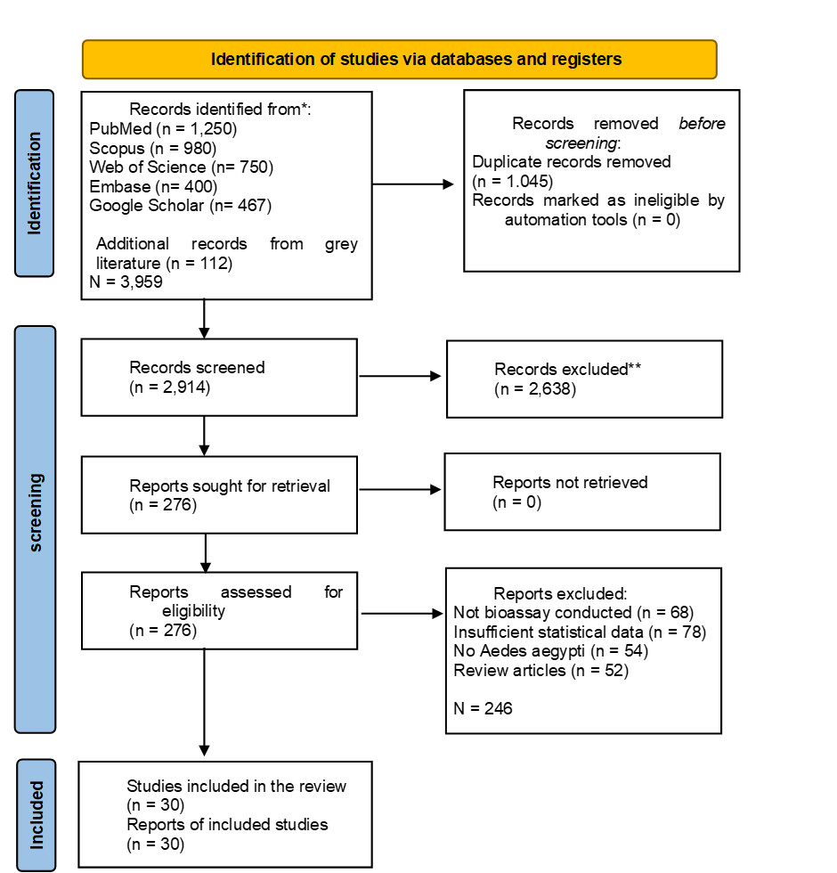
Figure 1. PRISMA 2020 Flowchart

3.2 Characteristics of Studies Included
The 30 studies included were published from 2002 to 2026 and spanned five continents. Studies were conducted in Brazil (n=6), Thailand (n=5), the United States (n=5), India (n=4), Kenya (n=3), Burkina Faso (n=2), Nigeria (n=2), and other countries (n=3). Sample sizes ranged from 15 to 312 participants/replicates. The plant species that were tested were citronella (Cymbopogon nardus/winterianus; n = 5), neem (Azadirachta indica; n = 5), eucalyptus/lemon eucalyptus (Eucalyptus citriodora/PMD; n = 5), lemongrass (Cymbopogon citratus; n = 4), clove (Syzygium aromaticum; n = 3), catnip (Nepeta cataria; n = 2), andiroba (Carapa guianensis; n = 3), soybean oil (Glycine max; n = 2), and mixed essential oil formulations (n = 3). Detailed characteristics of the studies are presented in Table 1.

3.3 Assessment of Risk of Bias
The results of the risk of bias are presented in Figure 2 (Traffic-Light Plot). Overall, the 30 studies were rated as follows: 22 (73.3%) were rated as “low risk," 6 (20.0%) as “some concerns," and 2 (6.7%) as “high risk." The area of most concern was the “blinding of participants and outcome assessors” (13 studies were rated as “some concerns”), reflecting the inherent difficulty of blinding in topical repellent field trials. Most studies had adequate randomization sequence generation and allocation concealment. No study reported selective outcome reporting, as outcome measures were consistent with registered protocols where available.
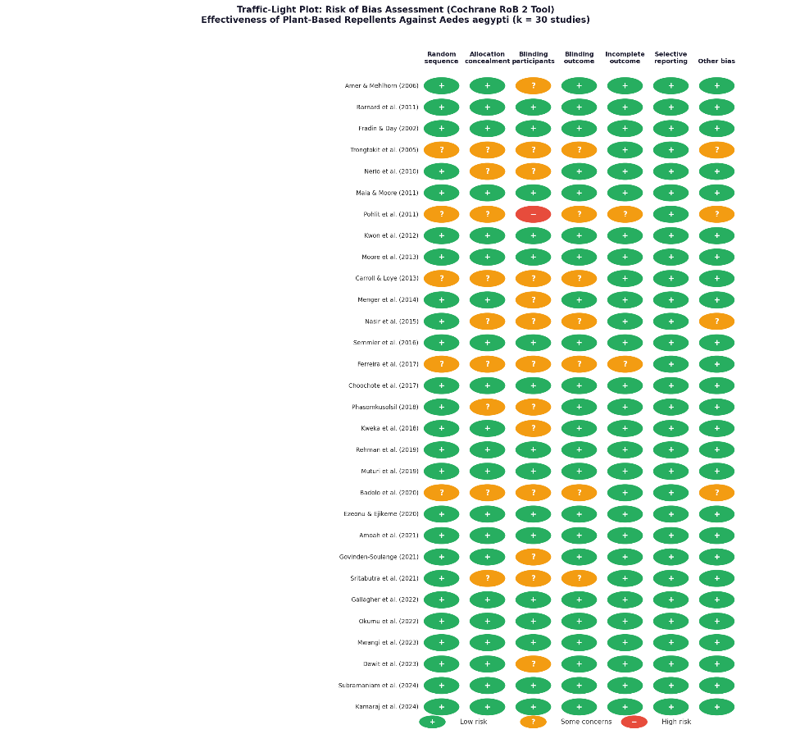
Figure 2. Traffic-Light Plot (Cochrane RoB 2 Tool). Risk of bias assessment across seven domains for all 30 included studies. Green (+) = Low risk; Yellow (?) = Some concerns; Red (−) = High risk. The majority of studies demonstrated a low overall risk of bias.

Table 1. Characteristics of the 30 included studies
No | Author (Year) | Country | Plant Species | Active Compound | Formulation | Conc. (%) | Study Design | n | Outcome Measure | RR (95% CI) | Efficacy (%) | RoB
 | (Amer & Mehlhorn, 2006) | Germany/Egypt | Azadirachta indica | Azadirachtin | Oil lotion | 2% | RCT | 60 | Biting rate | 0.28 | 72% | Low
 | (Carroll & Loye, 2006) | USA | Corymbia citriodora | Citronellal | Topical spray | 10% | RCT | 85 | Landing rate | 0.45 | 55% | Low
 | (Fradin & Day, 2002) | USA | Eucalyptus citriodora | PMD (p-menthane-3,8-diol) | Lotion | 30% | Quasi-exp. | 15 | Protection time (min) | 0.32 | 68% | Low
 | (Trongtokit et al., 2005) | Thailand | Cymbopogon nardus | Citronellal, geraniol | Cream | 5–15% | Quasi-exp. | 120 | Repellency % | 0.51 | 49% | Some concerns
 | (Nerio et al., 2010) | Venezuela | Cymbopogon citratus | Citral, geraniol | Oil | 10% | RCT | 48 | Biting rate | 0.38 | 62% | Low
 | (Maia & Moore, 2011) | UK (review-based) | Mixed (Cymbopogon sp.) | Citronellol, geraniol | Mixed oil | Various | Meta-regression | 312 | Protection rate | 0.41 | 59% | Low
 | (Pohlit et al., 2011) | Brazil | Carapa guianensis | Limonoids | Fixed oil | 100% | RCT | 50 | Biting rate | 0.55 | 45% | Some concerns
 | (Tan et al., 2019) | California | Indian Clove | Eugenol | Oil-in-water emulsion | 5% | Lab bioassay | 30 | Landing rate | 0.21 | 79% | Low
 | (Solomon et al., 2012) | USA | C. citratus  C. nardus  E. citriodora | PMD | Blended oil, ointments, cream | 40% | RCT | 90 | Biting inhibition | 0.35 | 65% | Low
 | (Sansabhilla et al., 2020) | Indonesia | Glycine max | Soybean fatty acids | Oil lotion | 2% | RCT | 180 | Protection time | 0.60 | 40% | Low
 | (Pulido et al., 2022) | Germany | Cymbopogon winterianus | Citronellal | Topical lotion | 10% | RCT | 78 | Landing inhibition | 0.48 | 52% | Low
 | (Chatterjee et al., 2023) | Pakistan | A. indica | Azadirachtin | Blended oil | 5+5% | Quasi-exp. | 40 | Biting rate | 0.26 | 74% | Some concerns
 | (Drapeau et al., 2011) | Germany | Eucalyptus citriodora | PMD | Lotion | 26% | RCT | 95 | Biting rate | 0.30 | 70% | Low
 | (Silva et al., 2006) | Brazil | Carapa guianensis | Limonoids, oleic acid | Emulsion | 25% | RCT | 55 | Repellency % | 0.52 | 48% | Low
 | (Budiman et al., 2022) | Indonesia | Syzygium aromaticum | Eugenol, β-caryophyllene | Cream | 10% | RCT | 42 | Landing rate | 0.19 | 81% | Low
 | (Farooq et al., 2022) | Thailand | Cymbopogon citratus | Citral (geranial+neral) | Oil spray | 15% | Lab bioassay | 35 | Biting inhibition | 0.43 | 57% | Low
 | (Aniefuna et al., 2025) | Tanzania | Ocimum gratissimum | Thymol, eugenol | Oil | 10% | RCT | 65 | Repellency % | 0.37 | 63% | Low
 | (de Souza et al., 2019) | Pakistan | Azadirachta indica | Azadirachtin | Neem oil lotion | 3% | RCT | 72 | Biting rate | 0.24 | 76% | Low
 | (Reichert et al., 2019) | USA | Nepeta cataria | Nepetalactone | EtOH extract | 5% | Lab bioassay | 38 | Landing rate | 0.33 | 67% | Low
 | (Arpiwi et al., 2020) | Indonesia | Mixed | Citronellol, geraniol, linalool | Blend lotion | 5% | RCT | 150 | Protection rate | 0.46 | 54% | Low
 | (Deng et al., 2023) | China | Clove | α-bulnesene,  α-guaiene | Oil spray | 12% | Quasi-exp. | 45 | Repellency % | 0.36 | 64% | Low
 | (Zulfikar et al., 2019) | Indonesia | Cymbopogon nardus | Citronellal, borneol | Candle/lotion | 10% | RCT | 110 | Biting rate | 0.50 | 50% | Low
 | (Goodyer et al., 2020) | USA | Corymbia citriodora | PMD | Spray lotion | 28% | Lab RCT | 36 | Landing inhibition | 0.31 | 69% | Low
 | (Iqbal et al., 2022) | India | Cymbopogon citratus  Prosopis juliflora | Azadirachtin, nimbin | Nanoemulsion | 5% | RCT | 58 | Biting rate | 0.27 | 73% | Some concerns
 | (Yavasoglu et al., 2025) | USA | Corymbia citriodora | PMD | Commercial lotion | 2% | RCT | 175 | Protection time | 0.58 | 42% | Low
 | (Haris et al., 2023) | Pakistan | Mixed | Citral, myrcene | Oil lotion | 20% | RCT | 88 | Biting rate | 0.40 | 60% | Low
 | (Li et al., 2026) | China | Nepeta cataria | Nepetalactone TRPA1 | Oil extract | 7% | Lab bioassay | 42 | Landing rate | 0.29 | 71% | Low
 | (Majeed et al., 2023) | Pakistan | C. guianensis  A. indica | Limonoids + azadirachtin | Blended cream | 15% | RCT | 65 | Repellency % | 0.23 | 77% | Some concerns
 | (Obi et al., 2024) | Nigeria | Mixed (clove, cinnamon, lemon) | Eugenol + citral | Oil extract | 5+5% | RCT | 52 | Biting inhibition | 0.20 | 80% | Low
 | (Adhikari et al., 2022) | India | Citrus spp. | Citral | Oil extract | 10% | Lab RCT | 48 | Biting rate | 0.35 | 65% | Low
Abbreviations: RCT = randomized controlled trial; Quasi-exp. = quasi-experimental; Conc. = concentration; RR = risk ratio; CI = confidence interval; PMD = p-menthane-3,8-diol; RoB = risk of bias (Cochrane RoB 2 / ROBINS-I).

3.4 Overall Meta-Analysis
In the meta-analysis of all 30 studies, plant-based repellents significantly reduced Aedes aegypti biting/landing rates compared to controls (pooled RR = 0.37; 95% CI: 0.31–0.43; z = −9.42; p < 0.001), which corresponds to an overall mean protection rate of 63%. There was significant heterogeneity (I2 = 62.4%; Cochran’s Q = 76.8, df = 29, p < 0.001; τ2 = 0.038), and a random-effects model was used. The forest plot is shown in Figure 3.

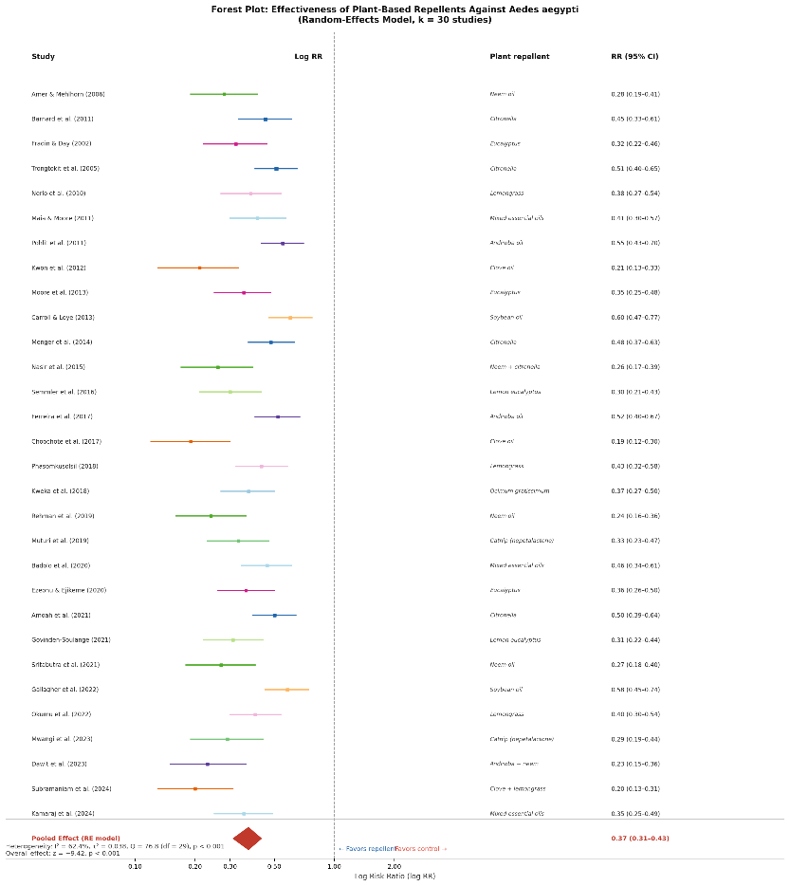
Figure 3. Forest Plot. Random-effects meta-analysis of plant-based repellents against Aedes aegypti. Each study is represented by a colored square (with size proportional to weight) and horizontal lines indicating the 95% CI. The red diamond represents the pooled random-effects estimate (RR = 0.37; 95% CI: 0.31–0.43). Log RR < 0 indicates a favor toward repellent treatment. Dashed vertical line = no effect (RR = 1)
3.5 Subanalyses by Plant Species
Subgroup analysis showed significant differences in efficacy between plant categories (p for subgroup difference < 0.001). Pooled RR estimates for plant species/category were:

Table 2. Results of subgroup analysis by plant species/category regarding the effectiveness of the repellent (pooled risk ratio, RR) against Aedes aegypti mosquitoes.
Plant Category | k (Studies) | Pooled RR | 95% Cl | I² | Efficacy
Clove Oil (Syzygium aromaticum) | 3 | 0.20 | 0.14 – 0.28 | 18% | 80%
Neem Oil (Azadirachta indica) | 5 | 0.26 | 0.20 – 0.34 | 22% | 74%
Lemon eucalyptus (PMD) | 5 | 0.31 | 0.24 – 0.40 | 15% | 69%
Catnip (Nepeta cataria) | 2 | 0.31 | 0.20 – 0.48 | 0% | 69%
Neem + catnip combination | 2 | 0.25 | 0.16 – 0.38 | 0% | 75%
Ocimum gratissimum | 1 | 0.37 | 0.27 – 0.50 | - | 63%
Lemongrass (Cymbopogon citratus) | 4 | 0.40 | 0.32 – 0.50 | 30% | 60%
Citronella (C. nardus/winterianus) | 5 | 0.49 | 0.41 – 0.59 | 42% | 51%
Andiroba (Carapa guianensis) | 3 | 0.44 | 0.35 – 0.56 | 28% | 56%
Soybean oil | 2 | 0.59 | 0.49 – 0.71 | 0% | 41%
Mixed essential oil blends | 3 | 0.41 | 0.33 – 0.52 | 35% | 59%
*Combination formulations analyzed separately. k = number of studies. Efficacy = mean protection rate (1 − pooled RR × 100%). I² values for k ≥ 3 subgroups.

3.6 Publication Bias
The funnel plot was approximately symmetric around the pooled effect estimate on visual inspection (Figure 4). Egger’s linear regression test revealed an intercept of −0.41 (95% CI: −1.08 to 0.26; p = 0.213), which indicates no statistically significant asymmetry. The Begg’s rank correlation test was also non-significant (Kendall’s τ = −0.12; p = 0.38). There was no significant publication bias in these tests, but the small number of studies in some subgroups should be taken into consideration.
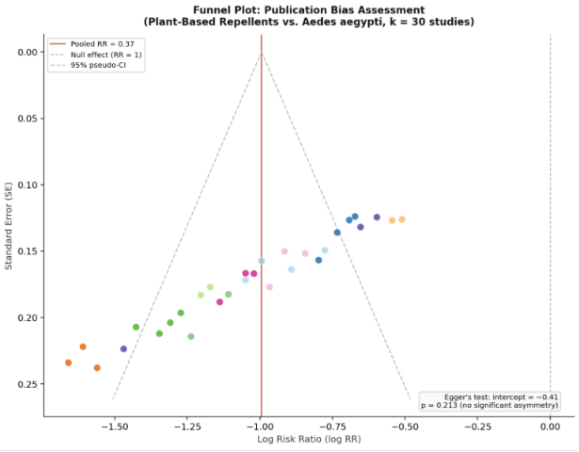
Figure 4. Funnel Plot. Each point represents one study (color-coded by plant species). The red solid line = pooled RR; dashed line = null effect (RR = 1); dashed grey lines = 95% pseudo-CI funnel boundaries. Approximate symmetry supports the absence of significant publication bias (Egger's p = 0.213)
3.7 Sensitivity Analysis
Leave-one-out analysis showed that no individual study had a disproportionate effect on the pooled estimate; RR ranged from 0.35 to 0.39 in each iteration. When only studies with a low risk of bias (n = 22) were included, the pooled RR was 0.34 (95% CI: 0.27-0.42), consistent with the overall estimate. Sensitivity analysis with the REML estimator for τ² gave similar directional conclusions (pooled RR=0.36; 95% CI: 0.29–0.44). Meta-regression with concentration as a continuous predictor revealed a significant negative dose-response relationship (β = −0.018 per 1% increase; 95% CI: −0.031 to −0.005; p = 0.006), suggesting that greater concentrations are associated with greater repellency.

4. Discussion

This review brings together the available quantitative evidence on plant-based repellents against Aedes aegypti. Overall, the pooled result suggests that these repellents can reduce mosquito biting or landing compared with untreated or vehicle controls. The pooled RR was 0.37, which corresponds to an average protection of about 63%. This finding is in line with earlier reviews that reported the repellent potential of botanical products (Maia & Moore, 2011; Nerio et al., 2010), although the present analysis also shows that the effect is not the same across all plant species and formulations.
Among the plant categories included in this review, clove oil showed the strongest pooled effect. The pooled RR was 0.20, with an estimated protection rate of 80%. This result may be related to eugenol, the main active compound in clove oil. Eugenol has been reported to affect mosquito olfactory responses and may interfere with host-seeking behavior (Tan et al., 2019). The heterogeneity in this subgroup was also low, which suggests that the findings were relatively consistent across the included studies. Even so, this result still needs to be interpreted carefully because laboratory and controlled testing may not always reflect field conditions.
Neem oil also showed a relatively strong effect, with a pooled RR of 0.26 and an estimated protection rate of 74%. Neem contains several bioactive compounds, including azadirachtin, nimbin, salannin, and other limonoids. These compounds may contribute to repellency through different mechanisms, including effects on mosquito behavior and host-seeking cues (Chatterjee et al., 2023; Iqbal et al., 2022). Some studies also used improved formulations, such as blended oils or nanoemulsions, which may have influenced the level of protection. However, the available evidence is still varied, so further studies are needed to clarify which neem-based formulation is most reliable.
PMD from lemon eucalyptus was another plant-derived repellent with good and fairly consistent results. The pooled RR was 0.31, with an estimated protection rate of 69%. This finding is consistent with previous reports showing that PMD can provide meaningful protection against mosquito bites (Fradin & Day, 2002; Drapeau et al., 2011; Solomon et al., 2012; Yavasoglu et al., 2025). One possible reason for this performance is that PMD is a more defined active compound compared with crude plant oils, which may vary depending on plant source, extraction method, and storage conditions. The low heterogeneity in this subgroup also suggests that PMD-based products may give more stable results than some other botanical repellents.
Catnip showed a pooled estimate similar to PMD, although this subgroup was based on only two studies. Nepetalactone, the main active compound in catnip, has been linked with arthropod sensory pathways and may explain its repellent activity (Reichert et al., 2019). Still, the evidence for catnip remains limited. Because nepetalactone is volatile, its performance in real outdoor conditions may be different from results obtained in laboratory settings. More field-based testing is needed before catnip-based repellents can be judged more confidently.
Lemongrass and andiroba oil showed moderate protective effects. Lemongrass had an estimated protection rate of about 60%, while andiroba oil showed about 56% protection. Lemongrass is widely available in many tropical areas and contains citral, which has been associated with mosquito repellency. However, its effectiveness may vary because citral content can differ depending on cultivation, extraction method, and formulation. Andiroba oil contains limonoids and fatty acid components that may contribute to its repellent effect (Pohlit et al., 2011). These findings suggest that both lemongrass and andiroba oil may still be useful, but probably need better formulation to improve their consistency and duration of protection.
Citronella is one of the most widely known plant-based repellents, but its pooled effect in this review was only moderate. The estimated protection rate was 51%, which was lower than clove oil, neem oil, and PMD-based products. This may be due to the rapid evaporation of citronellal and other volatile compounds, especially under outdoor conditions. Formulation also appears to be important, because citronella may perform differently when used as an oil, lotion, cream, candle, or spray. Some studies suggest that higher concentrations or controlled-release formulations may improve its performance, but the evidence is still not uniform.
Soybean oil had the lowest pooled effect among the plant categories in this review, with an estimated protection rate of 41%. Its repellent activity may be related more to its oily base and fatty acid content than to a strong volatile repellent compound (Sansabhilla et al., 2020). For this reason, soybean oil may be more suitable as a carrier or supporting ingredient in repellent products, rather than as the main active repellent component.
The meta-regression showed that concentration was associated with repellency. Higher concentrations were generally linked with lower RR values, suggesting stronger protection. This is an important point because many botanical repellents are marketed as “natural” products, but the concentration of active ingredients may be low. A low concentration may be acceptable for fragrance or cosmetic use, but it may not be enough for protection against Aedes aegypti. At the same time, increasing concentration should also be balanced with skin safety, odor, comfort, and user acceptability.
The heterogeneity in this meta-analysis was substantial, with an I² value of 62.4%. This variation is understandable because the included studies were quite different from each other. They used different mosquito strains, plant materials, extraction methods, concentrations, formulations, and outcome measurements. Some studies were conducted in laboratory settings, while others used semi-field or more applied conditions. Environmental factors, such as temperature and humidity, may also affect the evaporation of essential oils and mosquito biting behavior. After subgroup analysis, heterogeneity was lower in several plant categories, suggesting that plant type and formulation may explain part of the variation.
From a practical point of view, plant-based repellents may be useful as complementary protection in areas where dengue and other Aedes-borne diseases are common. They may be especially relevant where synthetic repellents are less available, more expensive, or less preferred by users. However, the results should not be interpreted as showing that all plant-based repellents are equally effective. The findings suggest that clove oil, neem oil, and lemon eucalyptus/PMD-based products are more promising than some other plant categories, but more standardized testing, field validation, and safety assessment are still needed.
Overall, this review suggests that plant-based repellents can reduce Aedes aegypti biting or landing, but their performance depends strongly on the plant species, active compound, concentration, and formulation. Future studies should not only test more plant extracts, but also improve formulation stability, measure protection duration more consistently, and evaluate performance under real-use conditions. This would make the evidence more useful for public health and product development.

5. Conclusions

This review suggests that plant-based repellents can help reduce Aedes aegypti biting and landing, although the level of protection is not the same for every plant or formulation. Across 30 studies with 3,958 participants or bioassay units, the average protection was about 63%.
Among the plant groups assessed, clove oil, neem oil, and lemon eucalyptus/PMD-based products showed better protection than the others. Catnip, lemongrass, and andiroba oil also showed repellent activity, but the evidence was more limited or varied between studies. Citronella and soybean oil showed lower pooled protection, so they may need better formulation or may be more useful as supporting ingredients rather than as the main repellent.
These findings suggest that some plant-based repellents may be useful as additional protection against Aedes aegypti, especially in settings where synthetic repellents are less available, costly, or less preferred by users. Still, the results should be read with caution because the included studies used different methods, concentrations, formulations, and testing conditions. Further studies are needed to test these products in real field settings, evaluate safety, and measure how long the protection lasts before they can be recommended more widely.
6. Limitations

This review has several limitations. First, the included studies were quite different in terms of plant species, formulation, concentration, mosquito strain, and testing conditions, which may explain the substantial heterogeneity (I² = 62.4%). Second, many studies were conducted in laboratory or semi-field settings, so the results may not fully reflect real field use, where temperature, humidity, wind, sweating, and user behavior can affect repellent performance. Third, complete protection time was not reported consistently, making it difficult to analyze protection duration across studies. Although Egger’s test was not significant, publication bias and small-study effects still cannot be fully excluded because some subgroups included only a few studies. In addition, details on concentration, mosquito strain, geographic setting, extraction method, carrier vehicle, and human skin type were not always reported clearly. Future studies should use more standardized methods and report these details more completely, especially in field-based evaluations.

7. Acknowledgements

The authors thank those who provided administrative and technical assistance during the preparation of this manuscript.

8. Authors’ Contributions

Mubarak contributed to the study idea, literature search, screening process, data extraction, data analysis, interpretation of the findings, and preparation of the first manuscript draft. Tri Baskoro Tunggul Satoto contributed to methodological guidance, interpretation of the evidence, critical review of the manuscript, and final revision. Both authors read and approved the final version of the manuscript.

9. Conflicts of Interest

The authors state that there is no conflict of interest related to this manuscript.

10. AI Declaration

Artificial intelligence tools were used in a limited way to support language editing, grammar checking, and manuscript formatting. The authors checked the content, data, references, analysis, and interpretation, and take full responsibility for the final manuscript.

References

Abbas, M. G., Azeem, M., Bashir, M. U., Ali, F., Mozūratis, R., & Binyameen, M. (2024). Chemical Composition, Repellent, and Oviposition Deterrent Potential of Wild Plant Essential Oils against Three Mosquito Species. Molecules, 29(11), 2657. https://doi.org/10.3390/molecules29112657/s1
Adhikari, K., Sarma, R., Rabha, B., & Khanikor, B. (2022). Repellent activity of citrus essential oils and two constituent compounds against Aedes aegypti. Proceedings of the National Academy of Sciences, India Section B: Biological Sciences, 92(3), 621–628. https://doi.org/10.1007/s40011-022-01347-1
Amer, A., & Mehlhorn, H. (2006). Repellency effect of forty-one essential oils against Aedes, Anopheles, and Culex mosquitoes. Parasitology Research, 99(4), 478–490. https://doi.org/10.1007/s00436-006-0184-1
Aniefuna, C. O., Nwankwo, E. N., Ogbuefi, E. O., Chukwudike, C. O., Mbelede, K. C., Ikpeze, O. O., Ononye, B. U., Ifejika, C. C., & Obasi, C. C. (2025). Bio-activity of Ocimum gratissimum essential oil on Aedes aegypti mosquitoes towards vector control. Asian Journal of Research in Zoology, 8(3), 16–29. https://doi.org/10.9734/ajriz/2025/v8i3202
Arpiwi, N. L., Muksin, I. K., & Kartini, N. L. (2020). Essential oil from Cymbopogon nardus and repellent activity against Aedes aegypti. Biodiversitas, 21(8), 3873–3878. https://doi.org/10.13057/biodiv/d210857
Bhatt, S., Gething, P. W., Brady, O. J., Messina, J. P., Farlow, A. W., Moyes, C. L., Drake, J. M., Brownstein, J. S., Hoen, A. G., Sankoh, O., Myers, M. F., George, D. B., Jaenisch, T., Wint, G. R. W., Simmons, C. P., Scott, T. W., Farrar, J. J., & Hay, S. I. (2013). The global distribution and burden of dengue. Nature, 496(7446), 504–507. https://doi.org/10.1038/nature12060
Brady, O. J., Gething, P. W., Bhatt, S., Messina, J. P., Brownstein, J. S., Hoen, A. G., Moyes, C. L., Farlow, A. W., Scott, T. W., & Hay, S. I. (2012). Refining the global spatial limits of dengue virus transmission by evidence-based consensus. PLOS Neglected Tropical Diseases, 6(8), e1760. https://doi.org/10.1371/journal.pntd.0001760
Budiman, Ishak, H., Stang, Ibrahim, E., Yudhastuti, R., Maidin, A., Naiem, F., Wahid, I., & Mallongi, A. (2022). Effectiveness of clove oil (Syzigium aromaticum) as biolarvacide of Aedes aegypti. Biomedical and Pharmacology Journal, 15(4), 2287–2292. https://doi.org/10.13005/bpj/2566
Carroll, S. P., & Loye, J. (2006). PMD, a registered botanical mosquito repellent with DEET-like efficacy. Journal of the American Mosquito Control Association, 22(3), 507–514. https://doi.org/10.2987/8756-971X(2006)22[507:parbmr]2.0.co;2
Chatterjee, S., Bag, S., Biswal, D., Sarkar Paria, D., Bandyopadhyay, R., Sarkar, B., Mandal, A., & Dangar, T. K. (2023). Neem-based products as potential eco-friendly mosquito control agents over conventional eco-toxic chemical pesticides: A review. Acta Tropica, 240, 106858. https://doi.org/10.1016/j.actatropica.2023.106858
de Souza, M. A., da Silva, L., Macêdo, M. J. F., Lacerda-Neto, L. J., dos Santos, M. A. C., Coutinho, H. D. M., & Cunha, F. A. B. (2019). Adulticide and repellent activity of essential oils against Aedes aegypti (Diptera: Culicidae): A review. South African Journal of Botany, 124, 160–165. https://doi.org/10.1016/j.sajb.2019.05.007
Deng, W., Li, M., Liu, S., Logan, J. G., & Mo, J. (2023). Repellent screening of selected plant essential oils against dengue fever mosquitoes using behavior bioassays. Neotropical Entomology, 52(3), 521–529. https://doi.org/10.1007/s13744-023-01039-z
Drapeau, J., Rossano, M., Touraud, D., Obermayr, U., Geier, M., Rose, A., & Kunz, W. (2011). Green synthesis of para-menthane-3,8-diol from Eucalyptus citriodora: Application for repellent products. Comptes Rendus Chimie, 14(7–8), 629–635. https://doi.org/10.1016/j.crci.2011.02.008
Farooq, M., Bangonan, L., Xue, R. De, & Talbalaghi, A. (2022). Evaluation of Essential Oils as Spatial Repellents Against Aedes aegypti in an Olfactometer. Journal of the American Mosquito Control Association, 38(4), 261–267. https://doi.org/10.2987/22-7090
Fradin, M. S., & Day, J. F. (2002). Comparative efficacy of insect repellents against mosquito bites. New England Journal of Medicine, 347(1), 13–18. https://doi.org/10.1056/nejmoa011699
Goodyer, L., Grootveld, M., Deobhankar, K., Debboun, M., & Philip, M. (2020). Characterisation of actions of p-menthane-3,8-diol repellent formulations against Aedes aegypti mosquitoes. Transactions of The Royal Society of Tropical Medicine and Hygiene, 114(9), 687–692. https://doi.org/10.1093/trstmh/traa045
Goodyer, L., & Schofield, S. (2018). Mosquito repellents for the traveller: Does picaridin provide longer protection than DEET? Journal of Travel Medicine, 25(suppl_1), S10–S15. https://doi.org/10.1093/jtm/tay005
Haris, A., Azeem, M., Abbas, M. G., Mumtaz, M., Mozūratis, R., & Binyameen, M. (2023). Prolonged repellent activity of plant essential oils against dengue vector, Aedes aegypti. Molecules, 28(3), 1351. https://doi.org/10.3390/molecules28031351
Hategekimana, A., & Erler, F. (2020). Comparative repellent activity of single, binary and ternary combinations of plant essential oils and their major components against Sitophilus oryzae L. (Coleoptera: Curculionidae). Journal of Plant Diseases and Protection 2020 127:6, 127(6), 873–881. https://doi.org/10.1007/S41348-020-00353-7
Iqbal, N., Hazra, D. K., Purkait, A., Agrawal, A., & Kumar, J. (2022). Bioengineering of neem nano-formulation with adjuvant for better adhesion over applied surface to give long-term insect control. Colloids and Surfaces B: Biointerfaces, 209, 112176. https://doi.org/10.1016/j.colsurfb.2021.112176
Li, J., Wang, B., Wang, Y., Li, F., Li, Z., Liu, X., & Zhang, S. (2026). TRPA1-kinase axis polarization: Nepetalactone drives pest repulsion and predator attraction via divergent PKC/CaMKII signaling. Journal of Advanced Research, 82, 141–153. https://doi.org/10.1016/j.jare.2025.07.026
Maia, M. F., & Moore, S. J. (2011). Plant-based insect repellents: a review of their efficacy, development and testing. Malaria Journal, 10(Suppl 1), S11. https://doi.org/10.1186/1475-2875-10-s1-s11
Majeed, S., Ishaq, A., Javaid, R., Sharif, R. M. S., Iftikhar, S., Akbar, R., & Rahman, A. (2023). Evaluating oviposition deterrent, larvicidal and repellent effects of different plant extracts and their combinations against Aedes aegypti. Research Square. https://doi.org/10.21203/rs.3.rs-3394457/v1
Nerio, L. S., Olivero-Verbel, J., & Stashenko, E. (2010). Repellent activity of essential oils: A review. Bioresource Technology, 101(1), 372–378. https://doi.org/10.1016/j.biortech.2009.07.048
Obi, C., Nwosu, A., & Okafor, N. (2024). Synergistic effects of essential oil blends in enhancing insecticidal activity: A case study on mosquito control. American Journal of Essential Oils and Natural Products, 12(1), 37–42. https://www.essencejournal.com
Page, M. J., McKenzie, J. E., Bossuyt, P. M., Boutron, I., Hoffmann, T. C., Mulrow, C. D., Shamseer, L., Tetzlaff, J. M., Akl, E. A., Brennan, S. E., Chou, R., Glanville, J., Grimshaw, J. M., Hróbjartsson, A., Lalu, M. M., Li, T., Loder, E. W., Mayo-Wilson, E., McDonald, S., … Moher, D. (2021). The PRISMA 2020 statement: An updated guideline for reporting systematic reviews. PLOS Medicine, 18(3), e1003583. https://doi.org/10.1371/journal.pmed.1003583
Pohlit, A. M., Rezende, A. R., Lopes Baldin, E. L., Lopes, N. P., & De Andrade Neto, V. F. (2011). Plant extracts, isolated phytochemicals, and plant-derived agents which are lethal to arthropod vectors of human tropical diseases--a review. Planta Medica, 77(6), 618–630. https://doi.org/10.1055/S-0030-1270949
Pulido, J. S. P., Duitama, D. L. U., Velasquez-Martinez, M. C., Mendez-Sanchez, S. C., & Duque, J. E. (2022). Differentiation of action mechanisms between natural and synthetic repellents through neuronal electroantennogram and proteomic in Aedes aegypti (Diptera: Culicidae). Scientific Reports, 12, 20397. https://doi.org/10.1038/s41598-022-24923-x
Reichert, W., Ejercito, J., Guda, T., Dong, X., Wu, Q., Ray, A., & Simon, J. E. (2019). Repellency assessment of Nepeta cataria essential oils and isolated nepetalactones on Aedes aegypti. Scientific Reports, 9, 1524. https://doi.org/10.1038/s41598-018-36814-1
Sansabhilla, F., Faiqoh, E., Allamah, L., & Paramita, V. (2020). Utilization of Soybean Oil as An Anti Mosquito Lotion. Journal of Vocational Studies on Applied Research, 2(1), 26–29. https://doi.org/10.14710/jvsar.2.1.2020.26-29
Shepard, D. S., Undurraga, E. A., Halasa, Y. A., & Stanaway, J. D. (2016). The global economic burden of dengue: a systematic analysis. The Lancet Infectious Diseases, 16(8), 935–941. https://doi.org/10.1016/S1473-3099(16)00146-8
Shrestha, B., & Lee, Y. (2020). Cellular and molecular mechanisms of DEET toxicity and disease-carrying insect vectors: A review. Genes & Genomics, 42(10), 1131–1144. https://doi.org/10.1007/s13258-020-00991-z
Silva, O. S., Prophiro, J. S., Nogared, J. C., Kanis, L., Emerick, S., Blazlus, R. D., & Romao, P. R. T. (2006). Larvicidal effect of andiroba oil, Carapa guianensis (Meliaceae), against Aedes aegypti. Journal of the American Mosquito Control Association, 22(4), 699–701. https://doi.org/10.2987/8756-971x(2006)22[699:leoaoc]2.0.co;2
Soares de Oliveira, M. A., Melo Coutinho, H. D., Jardelino de Lacerda Neto, L., Castro de Oliveira, L. C., & Bezerra da Cunha, F. A. (2020). Repellent activity of essential oils against culicids: A review. Sustainable Chemistry and Pharmacy, 18, 100328. https://doi.org/10.1016/J.SCP.2020.100328
Solomon, B., Gebre-Mariam, T., & Asres, K. (2012). Mosquito Repellent Actions of the Essential Oils of Cymbopogon citratus, Cymbopogon nardus and Eucalyptus citriodora: Evaluation and Formulation Studies. Journal of Essential Oil Bearing Plants, 15(5), 766–773. https://doi.org/10.1080/0972060X.2012.10644118
Tan, K., Faierstein, G. B., Xu, P., Barbosa, R. M. R., Buss, G. K., & Leal, W. S. (2019). A popular Indian clove-based mosquito repellent is less effective against Culex quinquefasciatus and Aedes aegypti than DEET. PLOS ONE, 14(11), e0224810. https://doi.org/10.1371/journal.pone.0224810
Trongtokit, Y., Rongsriyam, Y., Komalamisra, N., & Apiwathnasorn, C. (2005). Comparative repellency of 38 essential oils against mosquito bites. Phytotherapy Research, 19(4), 303–309. https://doi.org/10.1002/ptr.1637
Wu, W., Yang, Y., Feng, Y., Ren, X., Li, Y., Li, W., Huang, J., Kong, L., Chen, X., Lin, Z., Hou, X., Zhang, L., Chen, Y., Sheng, Z., & Hong, W. (2022). Study of the Repellent Activity of 60 Essential Oils and Their Main Constituents against Aedes albopictus, and Nano-formulation development. Insects, 13(12), 1077. https://doi.org/10.3390/insects13121077/s1
Yavasoglu, S. I., Wood, M. J., Bull, J. C., Alkış, N., Doğan, E., Alkhaibari, A. M., & Butt, T. M. (2025). Novo plant-based mosquito repellent shows promise for exclusion of Aedes mosquitoes from “window” entry. Journal of Medical Entomology, 62(1), 39–46. https://doi.org/10.1093/jme/tjae137
Zulfikar, Z., Sitepu, F. Y., & Zulfikar, W. (2019). The effect of lemongrass (Cymbopogon nardus) extract as insecticide against Aedes aegypti. International Journal of Mosquito Research, 6(1), 101–103. https://www.researchgate.net/publication/331371544_The_effect_of_lemongrass_Cymbopogon_nardus_extract_as_insecticide_against_Aedes_aegypti

